**SM-X Profile Update**

1. Check the update done by AISHA Tool. If the update says not resolved due to some issue, then proceed with below WA.
2. Check the DSL Order ID in Q Tool
3. If the PSUQ and Provider Queue is available, then use the below update query

insert into smx_queue values ('1482253_1', 'Clarify', sysdate,null,null,'register',0, null);

commit;

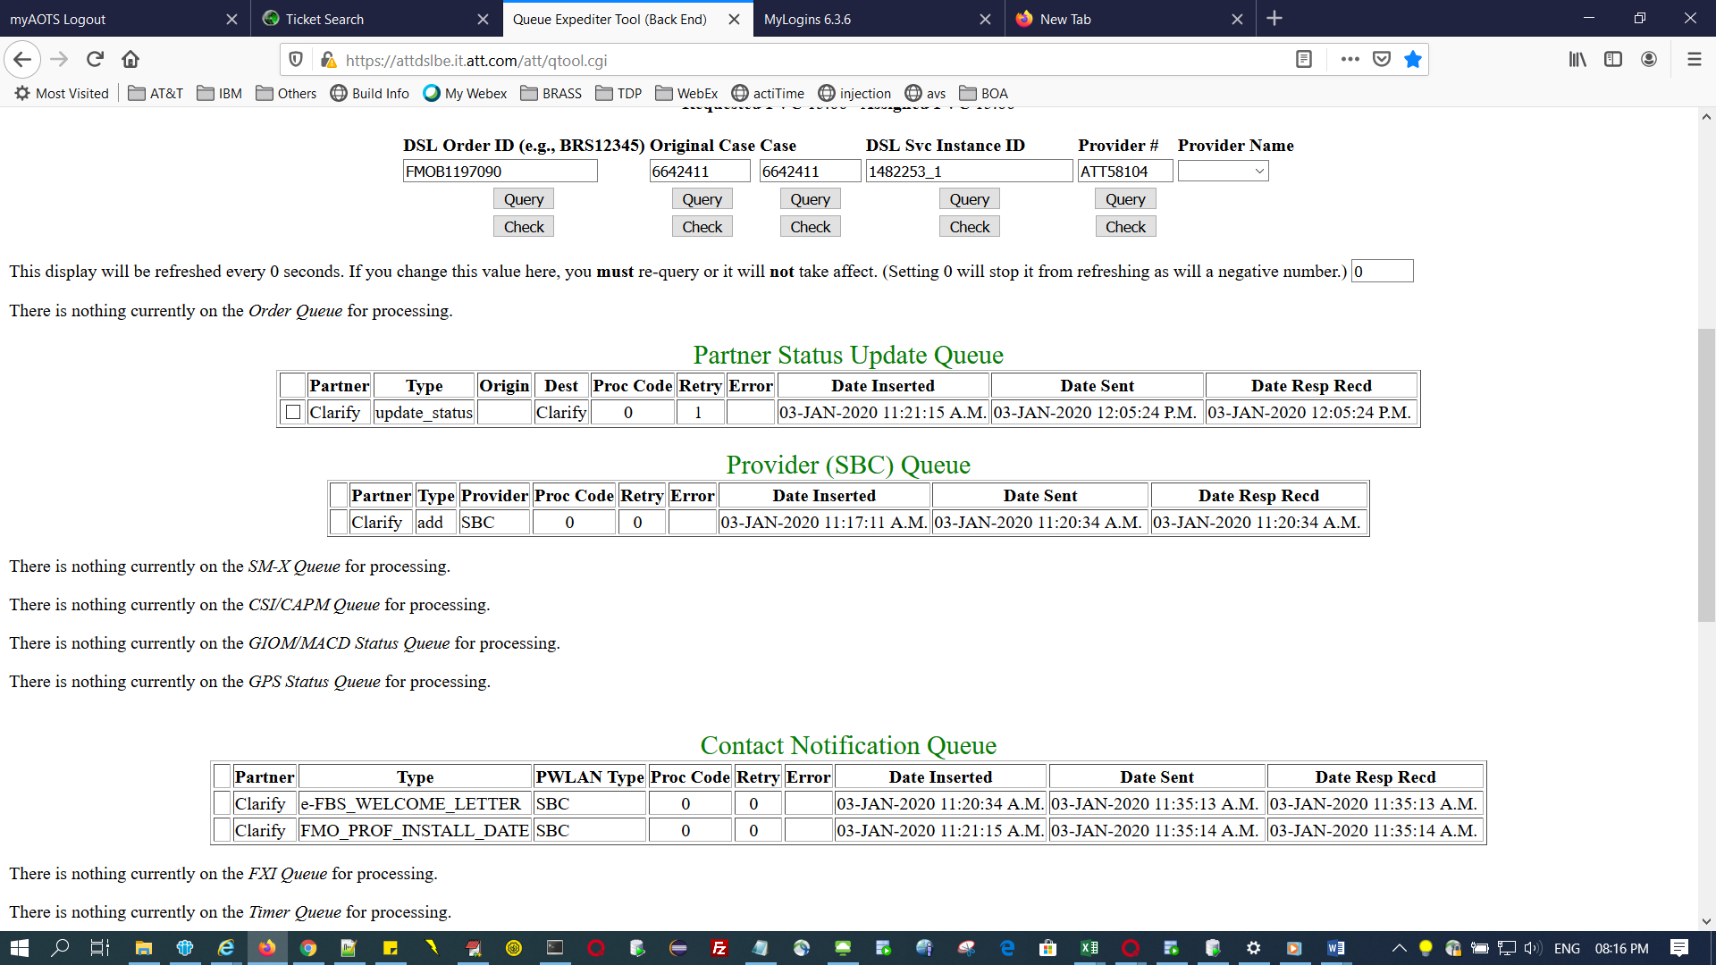

1. If the PSUQ is not available and SMX profile issue then do the below.
2. update provisioning_records set regist_userid=( select provisioning_case_number from provisioning_records where dslserviceinstanceid='1482333_1'), regist_passwd='1482333' where dslserviceinstanceid='1482333_1';
3. insert into smx_queue values ('1482333_1', 'Clarify', sysdate,null,null,'register',0, null);
4. Check the ip count for the order in Queue Expeditor Tool by clicking on the DBVals button in the bottom. If it is 1 – IP, then the ip start and end will be the same. If it is 5 ip the ip start and end will be as below(Count proper and keep only 5 ip’s). If it is 13, assign 13 ip as how it is here for 5 ip.
5. update provisioning_records set ip_state = 'IPs_Active', lan_mask= '255.255.255.248',

lan_router_ip = '99.159.42.38', available_ip_start = '99.159.42.33' , available_ip_end ='99.159.42.37', REQUESTED_PVC = '3.43',ASSIGNED_PVC = '3.43' where dslserviceinstanceid = '1482333_1';

1. update service_address set phone = '0880765811' where dslserviceinstanceid = '1482333_1';

1. update provisioning_records set provider_circuitnumber = '0880765811' where dslserviceinstanceid = '1482333_1';

**For below query (f), billingcode = case #, covadcircuitnumber=itn(Value of Phone in QTool), ordernumber = pick from provider data and add 1 (select ordernumber from provider_data where ordernumber like 'ATTT%' order by ordernumber desc; )**

1. insert into provider_data (DSLSERVICEINSTANCEID,PROVIDER,DATETIME_INSERTED,ORDERNUMBER,billingcode,covadcircuitnumber,status) values ('1482333_1','SBC',sysdate,'ATTT4604','6642501','0880765811','Pending');
2. If the order is already having the updates till 4.e in the above, then perform only the below step and then send the entry for PSUQ table in the QTool.

**For below query (f), billingcode = case #, covadcircuitnumber=itn(Value of Phone in QTool), ordernumber = pick from provider data and add 1 (select ordernumber from provider_data where ordernumber like 'ATTT%' order by ordernumber desc; )**

insert into provider_data (DSLSERVICEINSTANCEID,PROVIDER,DATETIME_INSERTED,ORDERNUMBER,billingcode,covadcircuitnumber,status) values ('1482333_1','SBC',sysdate,'ATTT4604','6642501','0880765811','Pending');

**Note:** After doing the above updates, entry in PSUQ will come after a little time once the updates are picked by Cron.